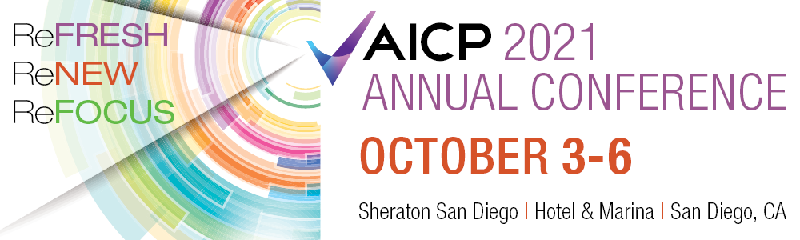
Date
Business Owner
Company Name
Address
City, State Zip

Dear ,
Beginning Sunday, October 3rd through 6th, The Association of Insurance Compliance Professionals (AICP) will host our annual national conference in San Diego, CA. You have played a huge role in the success of our organization for years. We can’t thank you enough for supporting us as a frequent sponsor. As part of our conference, we select a charity local to the area. This year we are supporting Mama’s Kitchen. Mama’s Kitchen prepares and delivers nutritious meals for those struggling with AIDS or cancer who are too sick to shop and cook for themselves in San Diego, California. Mama’s Kitchen also offers a number of other programs such as: AIDS Nutrition Program, Cancer Nutrition Program, Children’s Nutrition Program, Congestive Heart Failure Pilot Program, Type 2 Diabetes Nutrition Program, Chronic Kidney Disease Pilot Nutrition Program, Pantry Service, HIV Emergency Food Assistance, and Medical Nutrition Therapy.
In addition, the AICP provides a scholarship program for those looking to enter or advance their careers in our industry. All money raised during our fundraiser will be split between Mama’s Kitchen and our scholarship fund.
Please consider helping us with a product or service donation from your business. All donations are greatly appreciated and are tax deductible. Our attendees come from all areas of the country. Ideally, we are looking for donations that can be used by people anywhere. A night out on the town, a weekend at your favorite resort, a hotel or airline accommodations are items that people will get excited and encourage more bidding!
Our conference is expected to draw over 500 attendees via in person and virtually. Participating businesses will be prominently featured in our conference publications and website app.
A donation form is attached. Simply fill it out, then call or email us and we’ll help with the rest of the details. We request you provide us a picture of your donated item(s) and hold them until after the auction concludes on October 6th. An AICP silent auction committee member will be in touch with you shortly after the 6th to provide you with the winner’s name and address of where to ship your generous donation. Thank you for your consideration and participation in this year’s AICP annual conference. Your generosity will directly help Mama’s Kitchen and help further our strategic initiative of bringing more students from college into the insurance industry.
Cordially,
Auction Committee Representative
Association of Insurance Compliance Professionals
Phone: ( ) __________________
Email:

Thank you for making a contribution to our silent auction. Please complete this form and send it to michael.Hollar@combined.com.org.
Donor Representative Name: _________________________________________________
Donor Company Name:______________________________________________________
Mailing Address:____________________________________________________________
Physical Address:___________________________________________________________
EMAIL:____________________________________________________________________
Phone Number:__________________________

Description of item or service being donated
_________________________________________________________________________
_________________________________________________________________________
_________________________________________________________________________

Approximate Retail Value: ____________________

Thank you for your support!

Please return this form or email information with a picture of the item(s) to Michael Hollar, Michael.hollar@combined.com, by September 17, 2021.

Suggested Items
Outdoor Pergola Gazebo Jewelry
Fitness Mirror Home Gym Electronics
Peleton Trainer Package Store Certificates
Hotel Accommodations Sports tickets
Restaurant Certificates Art
Portable Putting Green Bowling Ball and Bag

